Query Optimization Using Index

Problem Statement
A query that searches products by name is running slowly when the table contains a large amount of data.
slow query:

SQL Query
CREATE INDEX idx_products_product_name
ON products(product_name);
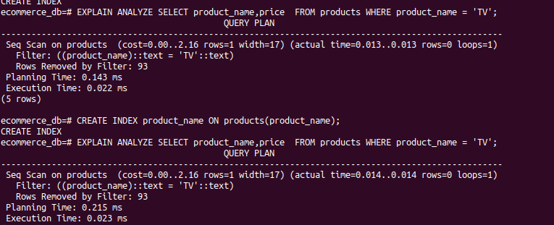

Theory – Why Indexing a Boolean Column is NOT Efficient

Explanation
Creating an index on a boolean column (such as is_active with values TRUE or FALSE) is usually not efficient because:
- Boolean columns have very low cardinality (only two possible values).
- An index works best when a column has many unique values.
- When most rows share the same boolean value, the database still has to scan many rows.
- In such cases, the database optimizer may ignore the index and perform a full table scan.

Conclusion
Indexes are most effective on columns with high uniqueness (like IDs, names, or emails).
Boolean columns usually do not benefit from indexing and can increase storage and maintenance cost.

